Read Me:
This document is for you to set up my “EcoNavigator”
Application you need to run the system: Download “PHPStorm” and “XAMPP” only this both will do.
Then Additional Control Panel: For Google and Facebook To setup the panel before using the OAuth login:
- https://console.cloud.google.com/
- https://developers.facebook.com/
Note: you have to setup your own panel only can used the “Login with Google or Facebook”
After you completed setup you will see this:
Google Panel:
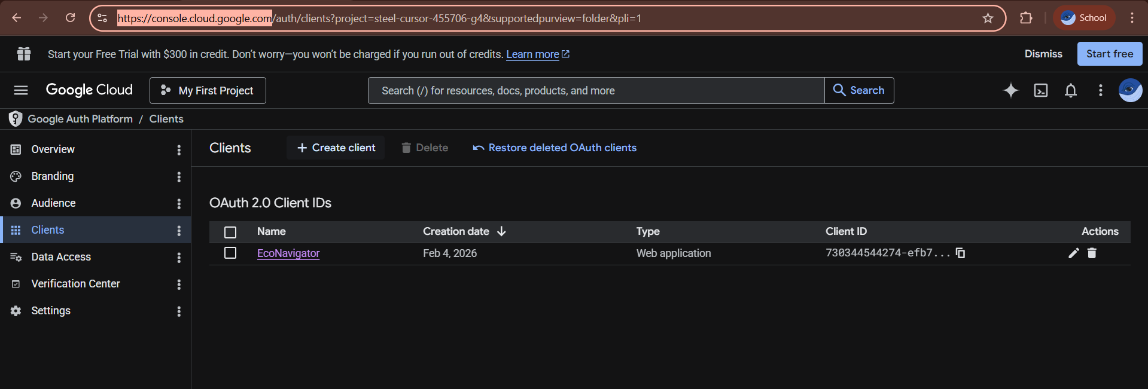
On these panel:
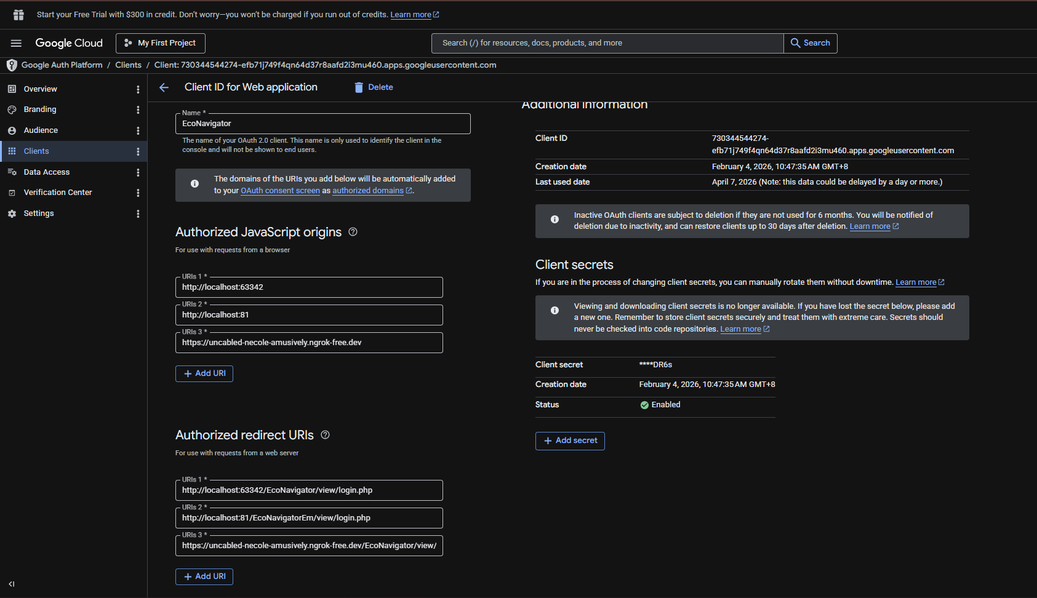
On this session: just put all the info of the login page according to your url so it will used
Here are the Facebook Panel:
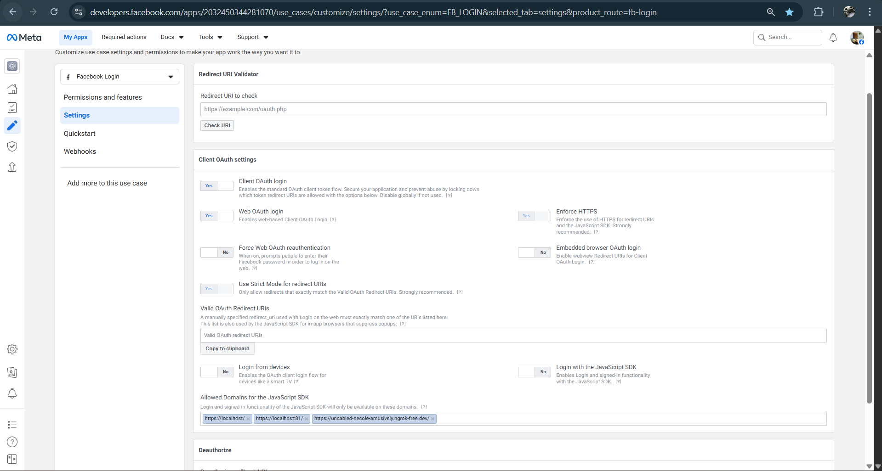
For Facebook, after u setup it will have this panel to start insert your login page pant of your url then it will work.
After do all the setup now is some changes of the code files on my EcoNavigator:
Follow the steps below to set up:
- Project Setup:
- Copy the main project folder.
- Paste it into your local development environment such as:
PhpStorm (with local server like XAMPP) or upload it to any hosting platform or server of your choice
- Database Setup:
- Locate the database file inside the project (usually in the Econavigtor folder when you click u will see two files (Index.php and Database file: EcoNavigator.sqlite))
- Import or connect the database using:
SQLite (recommended as it came with your local server from PhpStorm , if XAMPP is MySQL which you have to careful changing some of some code before import)
- Ensure the database is properly linked to the system.
- Configuration:
- Open the configuration file (e.g config folder inside it the config.php)
- Update the following based on your environment: Database path / connection settings
- Server settings (if required)
- Run the system:
- Open your browser
- Run the system using: Example: This if you straight run from the local server like PhpStorm it will auto provide for you : http://localhost:63342/EcoNavigator/view/dashboard.php
- If you using XAMPP to run the folder of the EcoNavigator folder must inside the xampp/htdocs/EcoNavigator so in the website the is http://localhost:81/EcoNavigator/index.php
- User Roles and Access (on the EcoNavigator we only have 3 Users: Guest, User, Admin)
- Guest: they no need to register any account: as they will straight away able to use the system when the system is running: They just not have “User Personalization Features”
# For the “User Personalization” is block from them like rating, add bookmark, write feedback, track history and more it will block from them until they register an account only can used.
- User: They able to login and have a “User Personalization Features” like what I mention above.
# Additional Feature for user is: if they forgot password they able to login page and click for forgot password. But the user must registered before as it will send the otp code to their registered email. If not the system will return not found.

Login Detail: (This user is already inside the database you can have a look):
Email: sc07210074dc@sentral.edu.my
Password: Jordon$123

- Admin: Able to manage charging station under manage location page on the header and for the Analysis it will allow the admin to print the report of each charging station for record.

Login Detail: (This admin is already inside the database you can have a look):
Username: Admin@gmail.com
Password: admin123
Notes
• Make sure your server (e.g., PhpStrom, XAMPP) is running before accessing the system.
• Ensure all file paths and database configurations are correctly set.
• For deployment, update configuration settings according to your hosting environment.

